**EXPERIMENT - 1**

**DATE: 26-09-2025**

**AIM:**

To create a simple cloud software application and provide it as a service using any cloud service provider to demonstrate software as a service (SaaS).

**PROCEDURE:**

**STEP 1:** Go to [Zoho.com](https://www.zoho.com/) in your web browser.

**STEP 2**: Click Sign In and log in with your Zoho account (create a free account if needed).

**STEP 3**: From the Zoho home page, choose Zoho Creator and select Create Application.

**STEP 4**: When prompted, enter a name for your application, for “Hospital Management System.”

**STEP 5**: Click Create to generate a new blank application workspace.

**STEP 6**: Inside the application builder, add a form—for this project you can create the key forms such as Docter Appointment, Patient Report and Payment Details.

**STEP 7**: Once the form(s) are saved, the cloud software application is created and ready to use or share as a SaaS demo.

**IMPLEMENTATION:**

**STEP1: GOTO ZOHO.COM**

**STEP 2: LOGINTOTHE ZOHO.COM**



**STEP 3: SELECT ONE APPLICATION**

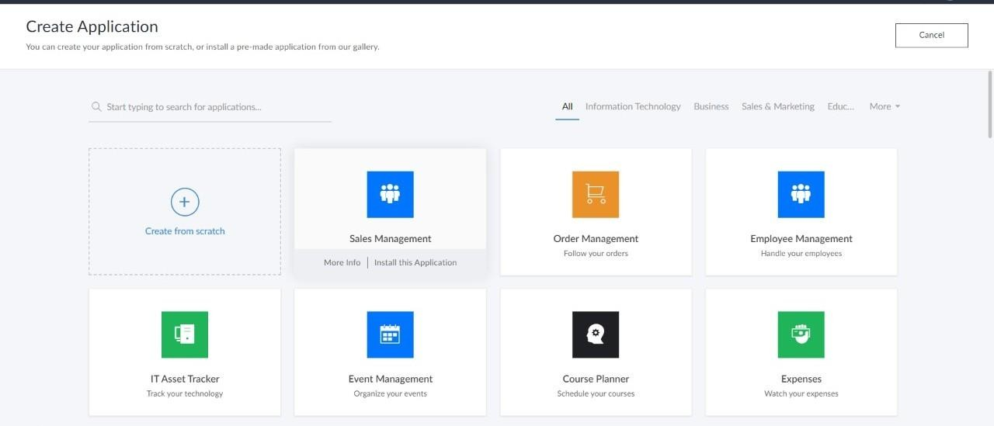

**STEP 4: ENTER APPLICATION NAME**

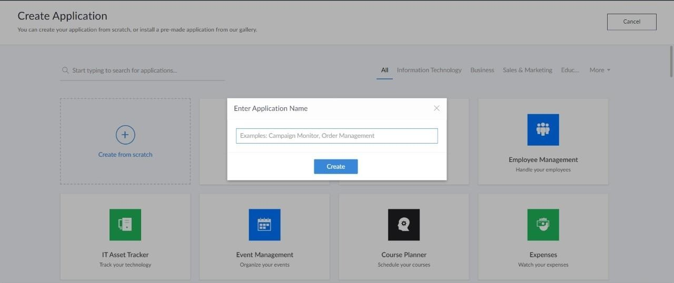

**STEP 5: CREATED NEW APPLICATION**

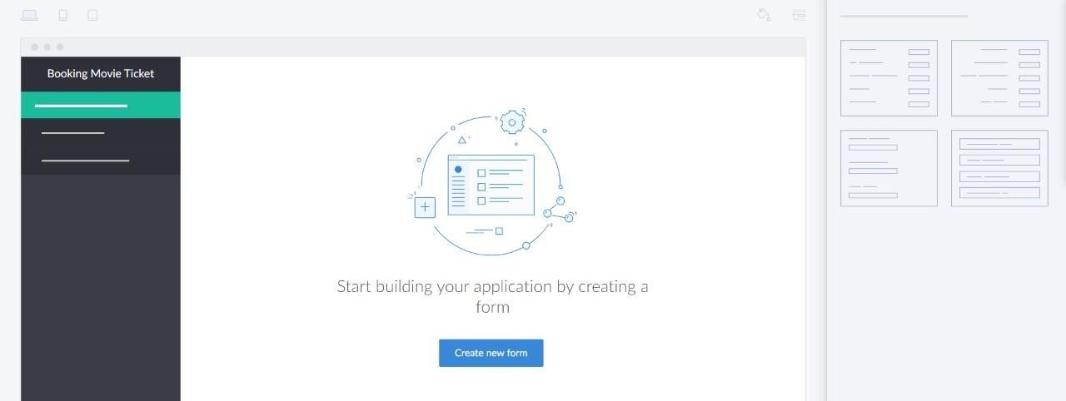

**STEP 6: SELECT ONE FORM**

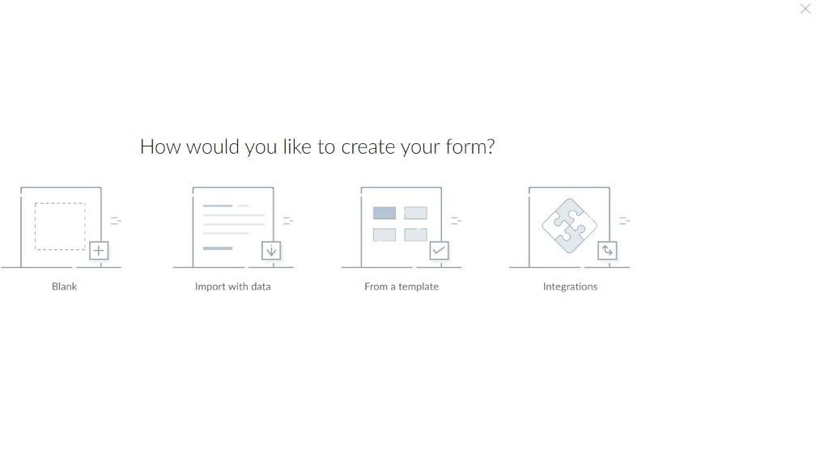

**STEP 7: THE SOFTWARE HASE BEEN CREATED.**

**OUTPUT;**



